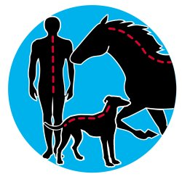

Zoë Heritage DC AMC MMCA
Chiropractic - The McTimoney way
for dogs, people & horses
The McTimoney methods is a gentle manipulative technique that works to balance and realign the patient's spine (horse, hound or human), helping to restore health, movement, soundness and performance.

Zoë is well qualified to treat people and animals, having profound knowledge of agility because she does it!
Trauma is not the only cause - rough play, pulling on lead, chasing balls and, of course, hitting/falling of pieces of agility equipment does not help!
Typical signs of dogs needing treatment may include:-
- Sudden loss of performance
- Knocking fences
- Uneven claw wear
- Difficulty getting into cars, climbing stairs
- Lack of enthusiasm for their work generally etc.
Veterinary permission is always gained before treating any animal.
More about McTimoney Chiropractic for animals and people.
The treatment takes it's name from John McTimoney who founded the technique. Originally developed for people, it is well known for its relatively gentle approach, making it an ideal animal treatment. Practitioners use their hands to make fast, precise adjustments.
The aim is to correct any misalignments that may be present in the spine and, therefore, help to restore health, movement, soundness and performance.
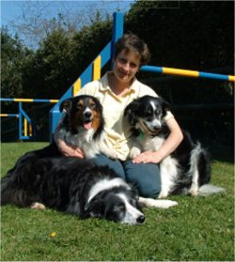
For more information,
please contact Zoë Heritage DC AMC MMCA
on 01747- 851503
(Shaftesbury, Dorset and at various shows)

