Devon Dogs Ltd
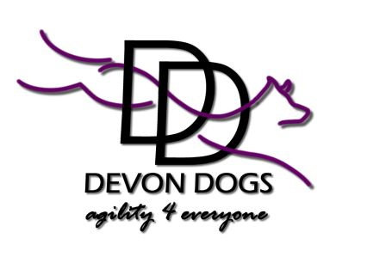
Business Address
East Bowerland Farm
Okehampton
Devon EX20 4LZ
07717 696623

Susan Garrett – Advances in Dog Training Seminar: Thursday 5thand Friday 6th May Contact & Weaves Seminar: Monday 9th May
Venue: Newhall Equestrian Centre, Budlake, Devon EX5 3LW 8.40am – 4.30pm

Advances in Dog Training Seminar
These 2 days are an opportunity for anyone interested in any aspect of dog training to hear it from one of the world’s best. This exciting program will review fundamental principles of dog training and work on improving your mechanics as a trainer.

Susan will show you how to apply learning theory into your everyday dog training. Understanding why your dog does what he does will help you work through training challenges facing you in any area of competitive dog training.

Learn how to teach your dogs both control for stationary positions (like contacts and sit stays) and incredible motivation so you will have a dog that WANTS to work at any skill you want to work on.

Susan will roll out what she feels are the 10 critical keys to an amazing performance sport dog, as well as give an insight in to using Classical Conditioning to your advantage in training (rather than allowing it to wreak havoc on the training).

Included in these days are some of Susan’s very popular games such as; the ItsYerChoice Game and a review of Susan’s very popular “Crate Games”. These two games form the foundation of Susan’s Say Yes Dog Training program which has helped many dogs become National or World Champions.

Come out and see why Advances in Dog Training has become so popular with performance, pet dog trainers and police dog trainers alike, all around the world.

Pre-requisite: In order to have a working spot in this seminar your dog must have worked up to at least level 3 of Crate Games (using Susan’s methodology as outline in her DVD by the same name).

Contact and Weave Seminar
Susan's innovate approach to dog training has allowed her to come up with her own unique system to teach both contacts and weaves. Her techniques are now taught throughout the world and successfully used by competitors worldwide. Some of the fastest stopped contact performances in the world come from dogs taught in Susan's nose touch system. Learn how to get your dog to run as fast over his contacts even if there is no treat or toy out there for him to see! This day will be a combination of lecture, demonstration as Susan will have her dogs accompanying her on this trip.

Included is a 2 hour presentation where Susan goes over the teaching of dogs to weave using her 2x2 method. This lecture covers both how to train the 2x2 as outlined on her DVD and also what is new about the method since the DVD was released.

Susan Garrett – Advances in Dog Training Seminar: Thursday 5thand Friday 6th May Contact & Weaves Seminar: Monday 9th May

Venue: Newhall Equestrian Centre, Budlake, Devon EX5 3LW 8.40 am – 4.30 pm

Susan Garrett Advances in Dog Training Seminar
£110 for 1 day | £180 for 2 days | £250 for all 3 days

All 3 days work in conjunction with each other and are not repeated. You can attend all 3 days; you can attend 2 days, or just the one day. You will need to have attended day 1 or day 2 to book on day 3. You cannot do just day 3 on its own.

We advise that you book early to avoid disappointment as places are limited, and bring your own lunch with you as there are no facilities at the venue.

Cancellation Policy Please note we operate a no refund policy for this seminar. If you are unable to attend any of your days, please inform me as soon as possible.

Option 1 By cheque made out to Devon Dogs Ltd and posted as above.

Option 2 By electronic transfer to account number 05366321, sort code 72-00-00, making sure you put your name as reference.

 …………………………………………………………………………………………………………………………………….

PLEASE COMPLETE A BOOKING SLIP FOR SUSAN GARRETT

Name:
Address:
Phone:
Email:
Day 1, 2 or 3

Payment must be received at time of booking by:
Cash / cheque / electronic transfer (please confirm)

