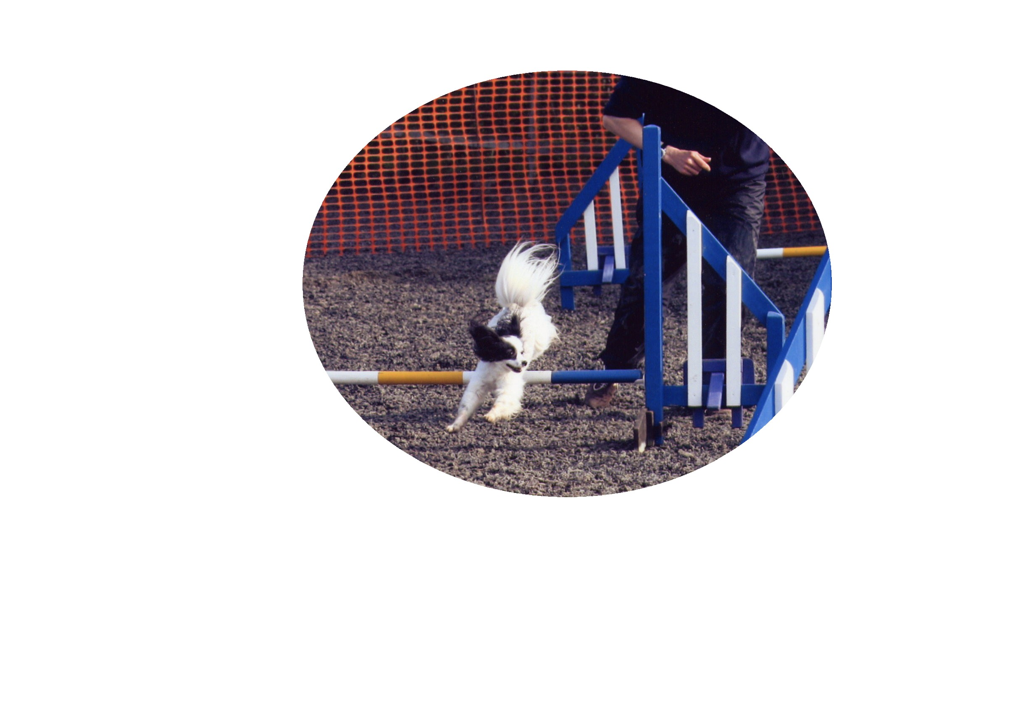
PAPILLON AGILITY LEAGUE
COMPETITION POINTS RECORD

Dog’s name:
Handler:

DATE | SHOW | CLASS | PLACE | POINTS
TOTAL POINTS

DATE SHOW CLASS PLACE POINTS
TOTAL POINTS

1st place = 20 points 8th place = 13 points 15th place = 6 points
2nd place = 19 points 9th place = 12 points 16th place = 5 points
3rd place = 18 points 10th place = 11 points 17th place = 4 points
4th place = 17 points 11th place = 10 points 18th place = 3 points
5th place = 16 points 12th place = 9 points 19th place = 2 points
6th place = 15 points 13th place = 8 points 20th place = 1 point
7th place = 14 points 14th place = 7 points CLEAR ROUND = 1 point

