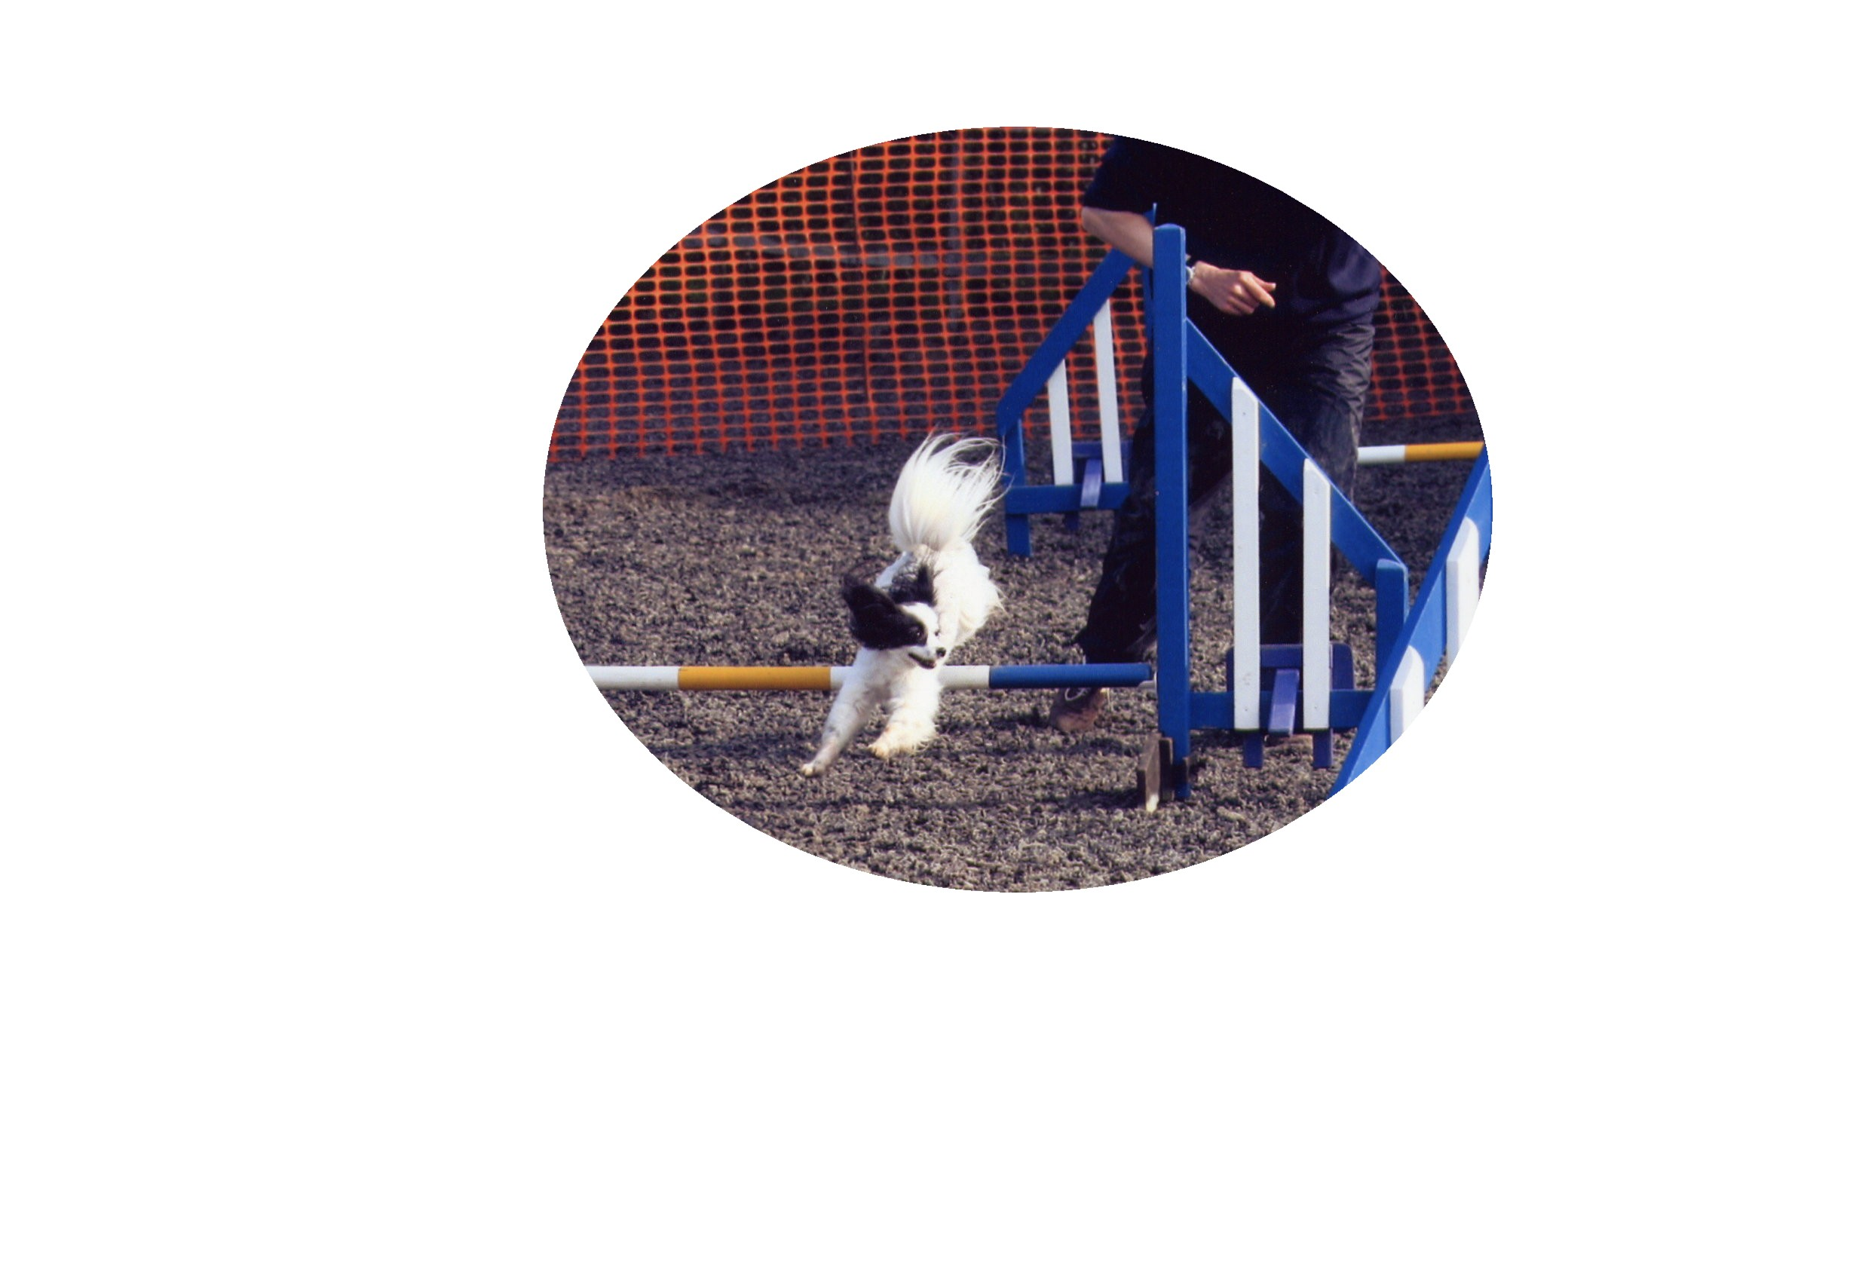
PAPILLON AGILITY LEAGUE REGISTRATION FORM

Name of handler: ……………………………………………………………………………………

Address: …………………………………………………………………………………

…….……………………………………………………………………………..

…………………………………………………………………………………….

Telephone number: …………………………………………………………………………………….

E-mail address: ……………………………………………………………………………………..

Name of dog: ………..……………………………………………………………………………

Age of dog: …………………………………………………………………………………….

Category of dog: ……………………………………………………………………………………

I agree to abide by the Rules and enclose £5.00 per dog.

Signed: ……………………………………………………………………………………………

Date: …………………………………………………………………………………………...

